GeoDT Documentation
Luke P. Frash
This documentation presents the data and methods used by GeoDT. This is a working document and therefore subject to change. Feedback and questions are appreciated.

Overview
Geothermal Design Tool evaluates fracture dominated geothermal reservoir performance and the associated economic performance. The tool is optimized for ensemble analysis and with the goal of helping to better inform high-level decision making when system uncertainty is high. In general, the predictions from GeoDT are less precise than a high-fidelity numerical simulator, such as ResFrac. However, the solutions can investigate a broader uncertainty space. This enables comprehensive evaluations when the design options are infinite.

Workflow
Optimized for computational efficiency, the workflow used by GeoDT uses sequential coupling of physics and economics modules (Figure 1). When required, iteration is used within each module and between modules. This includes Newton-Raphson iteration in the flow solver and guess-check iteration in the heat solver. Sequential iteration between the flow solver and fractures-and-wells module is used to simulate three-dimensional pressure-dependent fracture activation and growth. Sequential iteration between the heat solver and the flow solver is used to update flow results with temperature dependent properties.
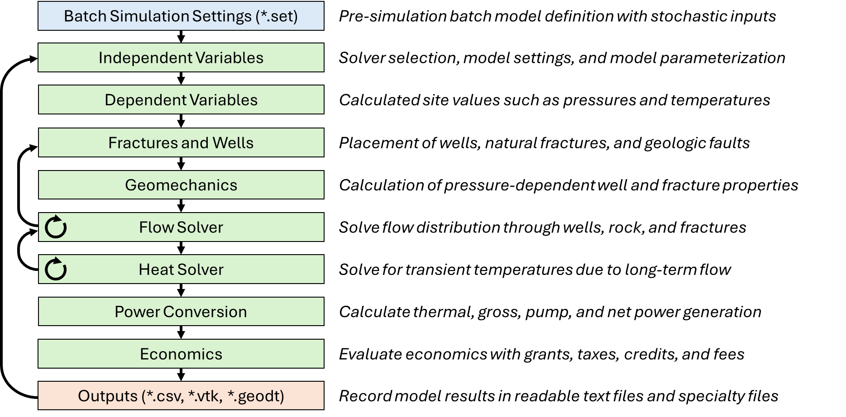
Figure 1. Typical workflow for a GeoDT batch simulation with stochastic model inputs. Data flow and iterative loops within and between modules are indicated by arrows.
Coupling between pressure-dependent fracture parameters (e.g., fracture conductivity as a function of net pressure) introduces severe numerical instabilities when these processes are tightly-coupled. Sequential coupling and adaptive boundary conditions help to solve these numerical instabilities.

GeoDT Reservoir Solvers
GeoDT offers two heat and flow solvers (Table 1). The basic solver is called by Strategy_Solver_type ‘gg’ and is best suited for moderate to high flow EGS with systematic fracture heterogeneity with no natural fractures. The advanced solver is called by Strategy_Solver_type ‘gt’ and is best suited for systems having permeable natural fractures.
Table 1. GeoDT solver options.
Solver Type | Basic (‘gg’) | Advanced (‘gt’)
Theoretical Basis | Gringarten et al., 1975 | Frash, 2021
Solver Speed | Fastest (<1 s/model) | Fast (15 s/model)
Supported Reservoir Types | EGS, KGS | AGS, CGS, EGS, KGS
Natural Fracture Effects | No | Yes
Fracture Thermal Interference | Yes | No
Maximum Fractures | 10000 | 250

The ‘gg’ solver is based on an analytical solution for heat production from ideal hydraulic fractured reservoirs [Gringarten et al., 1975]. The ‘gt’ solver uses an iterative pipe-network solver with heat and mass transport calculated for the wells and fractures [Frash, 2021]. The ‘gt’ solver supports performance prediction for closed-loop Advanced Geothermal Systems (AGS), fault-based Conventional Geothermal Systems (CGS), sand-propped Enhanced Geothermal Systems (EGS), and water-propped Caged Geothermal Systems (KGS).

Analytical Heat and Flow Solver Validation
Using the analytical EGS model, we validate proper execution of GeoDT (Figure 2) by reproducing Gringarten et al. (1975; Figure 3) which inspects thermal decline for four different reservoirs. Each has fractures with a 1 km² surface area that connect an injection well to a production well. The reservoir temperature is 300 °C with the injected fluid being 65 °C. The bulk flow rate is constant at 0.145 m³/s (1.45e10 cm³/s). The complete list of parameters is given in (Table 2), which includes corrections to the original Gringarten paper. Conversions are required to get from this table to the GeoDT inputs. Water thermal properties are computed by GeoDT using a lookup table based on the International Association for the Properties for Water and Steam (IPAWS-95).
Table 2. Parameters to match Gringarten et al., (1975) Fig. 5 validation.
Parameter | Value
Bulk Flow Rate | 0.145 m³/s
Fracture Area | 1 km²
Rock Temperature / Injection Temperature | 300 °C / 65 °C
Rock Thermal Conductivity | 2.549 W/m-K
Rock Heat Capacity | 2771.9 kJ/m³-K
Number of Fractures | 1 or 10
Fracture Spacing | 40 m, 80 m, 160 m, or infinite
Life Span | 100 yr
*Tortuosity / Flow Splits | 1.0 / 1.0
* Parameter required by GeoDT
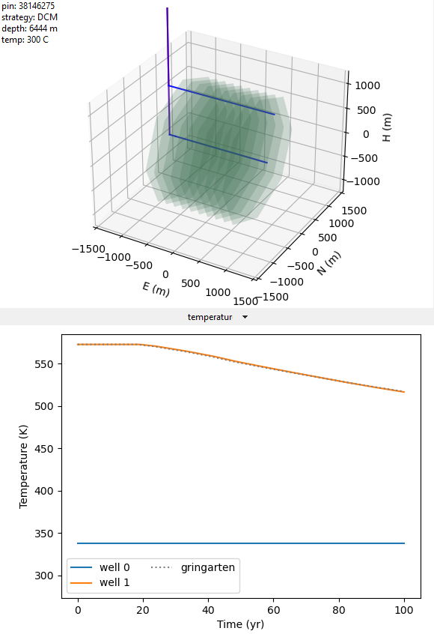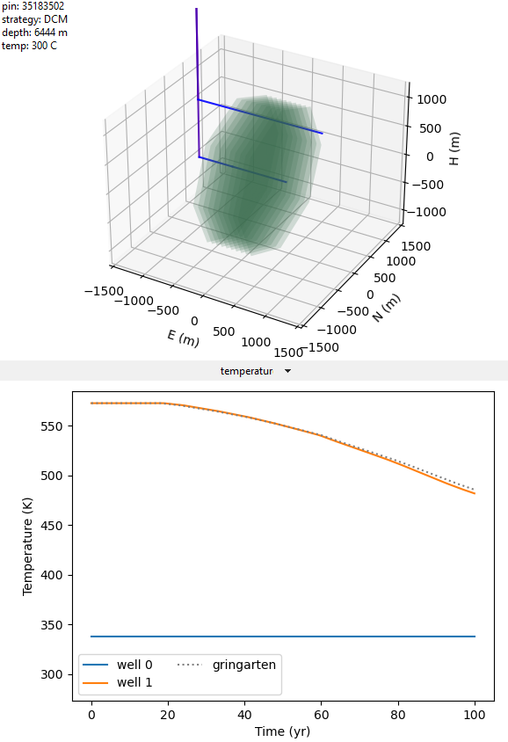
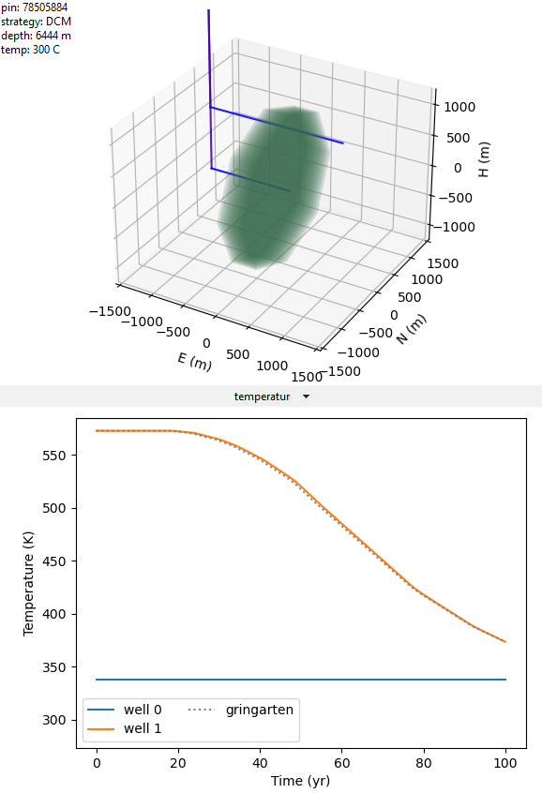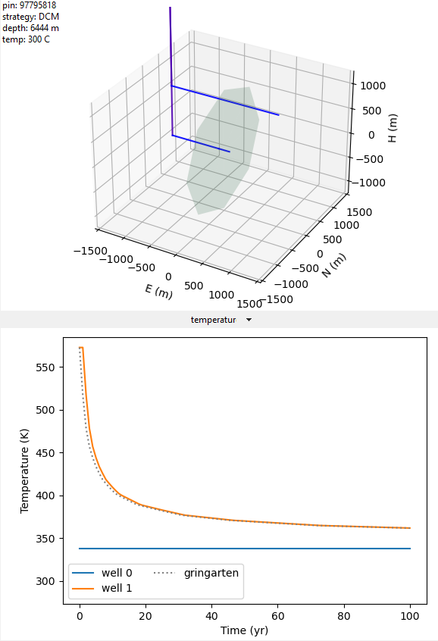
Figure 2. Validation of GeoDT’s ‘gg’ solver versus Gringarten et al. (1975) with 10 or 1 fracture at 1 km² area each.
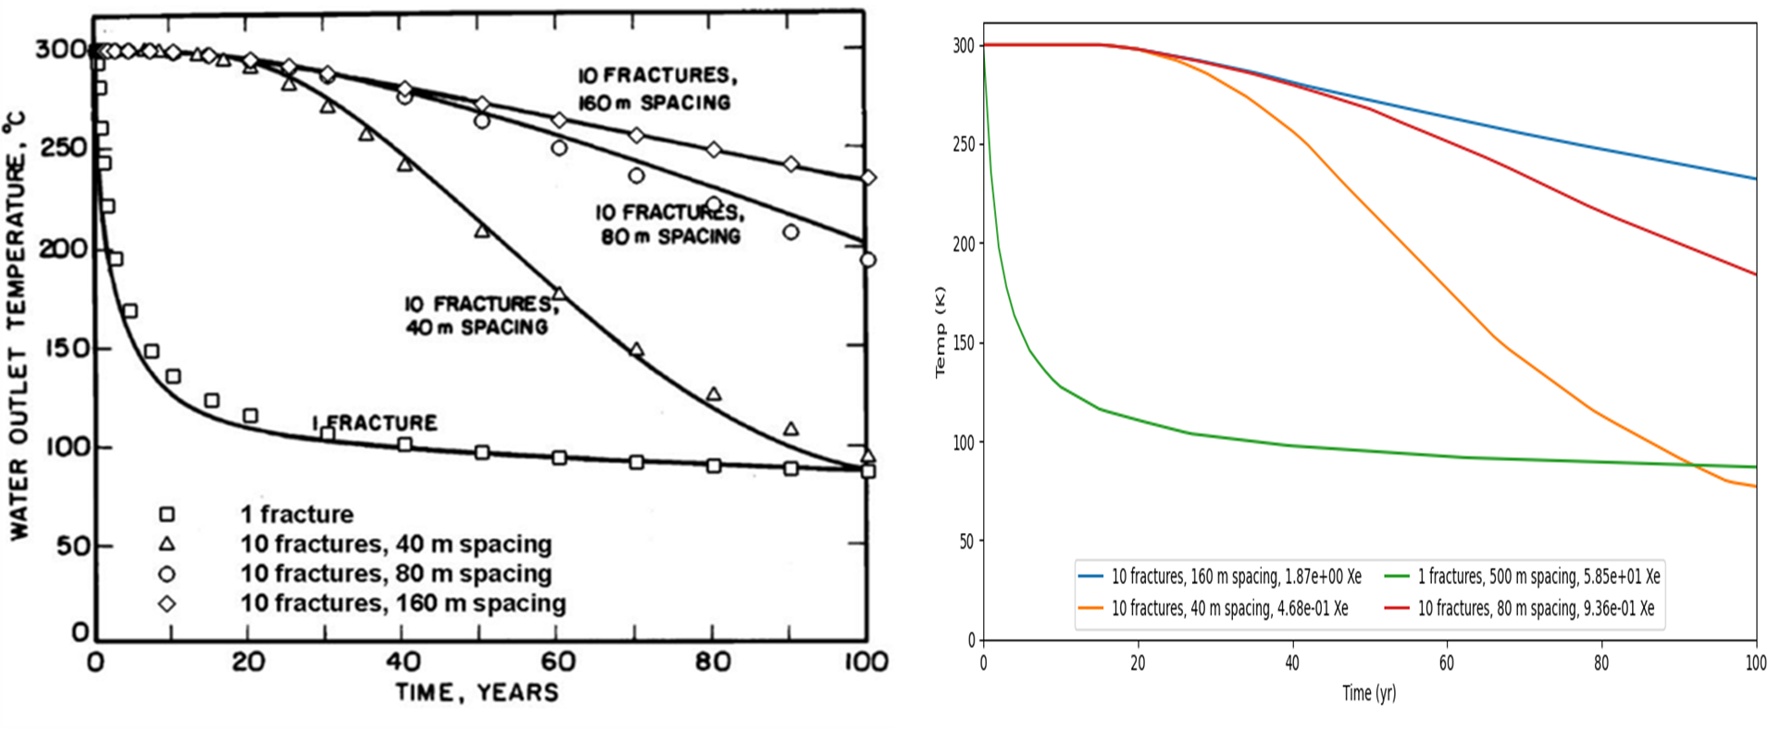
Figure 3. Reproduction of Fig.5 from Gringarten et al. (1975) using GeoDT’s ‘gg’ solver.
To reproduce this validation, the associated settings files for these four simulations are named “VALIDATION_GG01inf.set”, “VALIDATION_GG1040.set”, “VALIDATION_GG1080.set”, and VALIDATION_GG10160.set”.

Pilot Scale EGS Validation
The public datasets that are accessible for EGS validation include Fenton Hill New Mexico (Fenton), Blue Mountain Nevada (Project Red), the Frontier Observatory for Research in Geothermal Energy (FORGE), EGS Collab South Dakota (Collab), Soultz-sous-Forêts (Soultz), Pohang Korea (Pohang), Puu Honuaula Hawaii (DCHE), and Hijiori Japan (Hijiori). No data set has yet observed the long-term performance of EGS (Table 3Table 1).
Table 3. Overview of publicly available data sets for model validation.
Dataset | Benefits | *Drawbacks
Fenton Hill New Mexico (Fenton) | Volcanics and granitic rock; hydraulic stimulation data; microseismic data; and more than 170-days of flow tests at 105 gpm (0.0066 m3/s) | As the first ever study of EGS, the work had many interruptions and many variables. The flow rate was too low to see thermal effects. No sand proppant was used.
Blue Mountain Nevada (Project Red) | Diorite and granite with overlying sedimentary rock; data for well drilling and completions; down-hole flow and temperature data; multi-stage limited-entry well stimulation with sand proppant; 37-day flow test at 750 gpm (0.047 m3/s). | The circulation test is too short to validate thermal model behavior. Longer-term data withheld from public view. Claims is study pick from minima and maxima, rather than average performance.
Frontier Observatory for Research in Geothermal Energy Utah (FORGE) | Granite, gneiss, and diorite rock; data for drilling and stimulation, down-hole temperature/tracer data; microseismic data; multi-stage well completion with sand proppant; data used for testing other numerical models; 30-day flow test at 420 gpm (0.026 m³/s) | The circulation test is too short to validate thermal model behavior. Experiment plans do not include long-term high-rate circulation. An adjacent site is actively being developed without a meaningful public data release.
EGS Collab South Dakota (Collab) | Schist and amphibolite rock; dense data and instrumentation; detailed site data and models; 10-m scale testbed; 300-day circulation test at only 0.1 gpm (0.0000067 m³/s). | Excessively low flow rate and a diffuse production zone with flow from 4 wells and a mine drift. Monitoring wells interfered with flow through the site.
Soultz-sous-Forêts (Soultz) | Metamorphic and hydrothermal altered granite rock; three wells to >5000 m depth; seismic data; power is delivered to the grid; 3-years of production data at 436 gpm (0.0275 m³/s) | Data is tricky to find. Flow rates were reduced after triggered seismicity at the site. Flow interacts with several faults.
Pohang Korea (Pohang) | Granitic basement rock; two 4300 m deep wells; stimulation data with soft-cyclic-injection; largest triggered earthquake at an EGS site at Mw 5.5. | Project canceled after a large earthquake was triggered during deep well stimulation in this strike-slip crustal stress regime.
Puu Honuaula Hawaii (DCHE) | Coaxial borehole heat exchanger with detailed data that is often used for closed-loop well model validation. | Not an EGS project.
Hijiori Japan (Hijiori) | Granodiorite rock; three wells drilled to 2300 m depth and one to 1800 m depth; high-quality microseismic data; 90-day flow test at <840 bpm (0.053 m3/s). | All wells were predominantly vertical while the stress regime was complex normally faulted. This results in poor hydraulic connectivity.
*To date, no field dataset is sufficient to validate long-term thermal drawdown models.

Blue Mountain Nevada (Project Red)
Modeling reservoir performance at Blue Mountain Nevada can take more than one approach. When field data is already available, the most common approach is history matching. This compares models to observations to verify that the outcome can be predicted and to infer site properties that were not known before the field test. Alternatively, the Monte-Carlo approach uses ensembles of models with ranges of inputs based-on what was known before the field data was obtained. Results are compared to observations to test whether the actual outcome was within the forecast range of possibilities. Our validation of GeoDT uses Monte-Carlo and history matching. This approach helps contextualize how Blue Mountain performed in comparison to what could have reasonably been expected. Lacking long-term flow data, it is not yet possible to validate thermal drawdown behavior for the field site. Likewise, details omitted from public record, such as the estimated well friction, reduce history-match accuracy.
The complete set of simulation inputs are provided in “PRED_HISTMATCH.set” with a summary of inputs that best match the field data presented here (Figure 4).
Table 4. Overview of history-matched GeoDT models for Blue Mountain EGS using 2000 scenarios.
Input Metrics
Parameter | Unit | Target | Best to Target |  |  | Top 50 |  |  | Min | Max
Injection Rate | gpm | 803.2 | 803.1 |  | 0.0% | 803.1 | ± | 0.0% | 0.0% | 0.0%
Tortuosity | ratio | 0.707 | 0.707 |  | 0.0% | 0.707 | ± | 0.0% | 0.0% | 0.0%
Reservoir Temp | C | 185.3 | 185.3 |  | 0.0% | 185.3 | ± | 0.0% | 0.0% | 0.0%
Production Pressure | psi | 200 | 200 |  | 0.0% | 200 | ± | 0.0% | 0.0% | 0.0%
Fracture Closure Pressure | psi | 2300 | 2300 |  | 0.0% | 2300 | ± | 0.0% | 0.0% | 0.0%
Fitting Parameters
Parameter | Unit | Target | Best to Target |  |  | Top 50 |  |  | Min | Max
Injection Pressure | psi | 1780.3 | 1775.2 |  | -0.3% | 1778.1 | ± | 2.5% | -34.2% | 293.8%
Production Temperature | C | 168.9 | 179.0 |  | 6.0% | 179.3 | ± | 0.7% | -0.8% | 0.7%
Production Rate | gpm | 670.0 | 670.5 |  | 0.1% | 670.6 | ± | 1.2% | -1.3% | 1.5%
Resulting Parameters
Parameter | Unit | Target | Best to Target |  |  | Top 50 |  |  | Min | Max
Fracture Conductivity | mDft | 350 | 233 |  | -33.4% | 230 | ± | 5.2% | -81.3% | 72.6%
Stimulation Pressure | psi | 7485 | 7276.6 |  | -22.8% | 7276.5 | ± | 0.0% | 0.0% | 0.0%
Proppant Permeability | D |  | 106 |  | -54.3% | 107 | ± | 10.0% | -81.1% | 89.1%
Proppant Compressibility | 1/GPa |  | 49.52 |  | 0.0% | 44.38 | ± | 13.1% | -9.9% | 12.6%
Economic Metrics
Parameter | Unit | Target | Best to Target |  |  | Top 50 |  |  | Min | Max
Drilling Time | day | 131 | 27 |  | -79.6% | 27 | ± | 0.0% | 0.0% | 0.0%
Drilling Cost | $M |  | -4.826 |  | 0.0% | -4.826 | ± | 0.0% | 0.0% | 0.0%
Stimulation Cost | $M |  | -13.855 |  | 0.0% | -13.976 | ± | -3.1% | -2.5% | 2.8%
Facilities Cost | $M |  | -17.943 |  | 0.0% | -17.963 | ± | -0.5% | -0.5% | 0.5%
Pumping Cost | $M |  | -5.957 |  | 0.0% | -6.294 | ± | -30.1% | -42.0% | 83.0%
Operations Cost | $M |  | -7.036 |  | 0.0% | -7.410 | ± | -30.0% | -77.8% | 63.9%
Electricity Sales | $M |  | 22.701 |  | 0.0% | 23.547 | ± | 28.7% | -70.5% | 51.2%
NPV | $M |  | -21.085 |  | 0.0% | -21.171 | ± | -15.7% | -44.4% | 41.0%
LCOE | $/MWh |  | 546.055 |  | 0.0% | 545.6485 | ± | 18.3% | -28.7% | 1796.2%
IRR | % |  | neg. |  |  | neg.
CO2 Offset | car-yr |  | 5699.55 |  | 0.0% | 5847.904 | ± | 26.4% | -95.9% | 60.0%

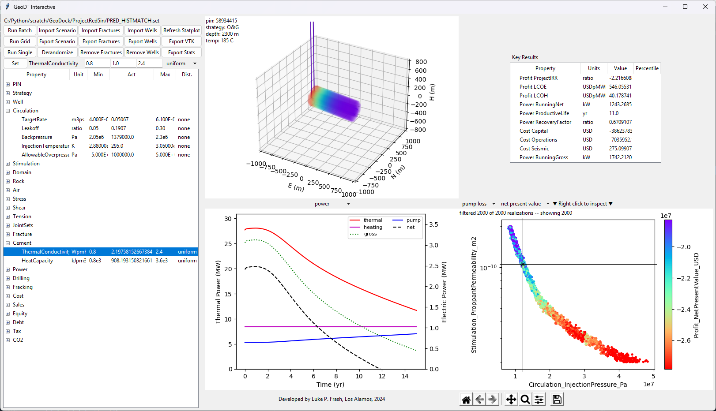
Figure 4. Best fit from history match ensemble with model input parameters derived from field data.
This result shows that a fracture conductivity of 233 mD-ft enables a match for injection pressure when the tortuosity factor is close to 0.707. The related proppant permeability is 106 Darcy with an average concentration of 0.064 m3/m3 (0.81 lb/gal) in the frac water.
The tortuosity factor of 0.707 is applied in two ways. First, it reduces the number of active hydraulic fractures proportional to the number of perforation clusters. In this case with 101 clusters, the number of active fractures reduces to 70. Second, it modifies flow heterogeneity through fractures. A tortuosity of 1 gives uniform flow per the Gringarten solution. A tortuosity of 0 concentrates all the flow through one fracture. A tortuosity of 0.7 gives a distribution that matches the spinner-log field data (Figure 5). Arguably, the number of active fractures and the heterogeneity of flow through those fractures will be two unique numbers. Combining the two into a single coefficient simplifies the parameterization process while leveraging the practical understanding that having more fractures will help counteract the negative effects of the fewer fastest flowing fractures.
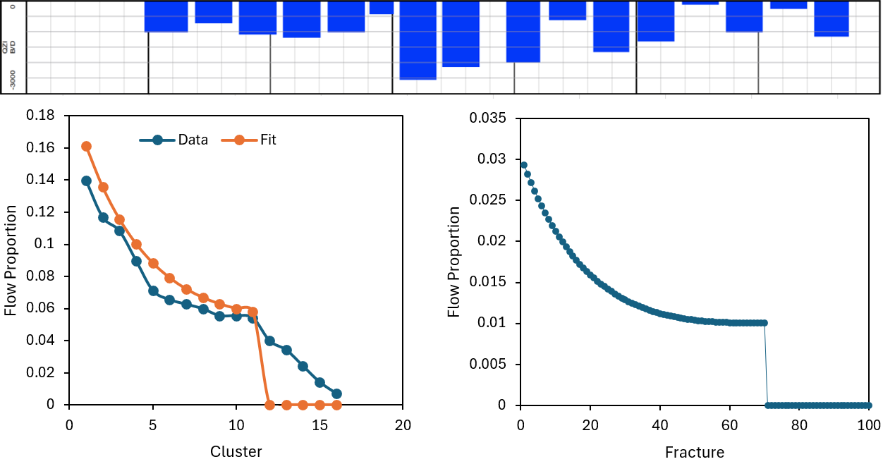
Figure 5. GeoDT’s tortuosity factor enables flow heterogeneity modeling to match the Blue Mountain field data (Norbeck and Latimer, 2021). (Top) spinner log data shown as flow per fracture cluster. (Left) Sorted data matched to the tortuosity factor of 0.707. (Right) Discretization for 101 fractures rather than the logged data for 16 clusters.
The history match does well for all parameters, with the production temperature match being the weakest. This disagreement stems from a lack of detail for well the design, uncertainty in reservoir temperature, and systematic error in GeoDT’s thermal solver that biases to slow heat transfer. The result is insensitive to the well cement’s thermal conductivity and heat capacity. This results in a slight overprediction of performance.
There is also discrepancy when comparing the published fracture conductivity estimate of 300 to 400 mD-ft, and GeoDT’s estimate of 233 mD-ft. Our model includes the 7” OD well casing for the injection well and a 5” OD well liner for the production well. GeoDT assumes uniform proppant placement and a square flow area while details for the published values are vague. Meanwhile, it is noted that lower conductivities than the published estimate are more typically observed.
The field data includes injection step-rate tests that we can compare to GeoDT’s history matched scenario (Figure 6). Here, we vary the circulation injection rate across 100 scenarios and model the pressures that coincide with each rate. Each scenario assumes a full 15-year production cycle at a constant flow rate. The linear pressure versus flow rate field data matches well to the model with the pressure loss dominated by flow through the fractured reservoir.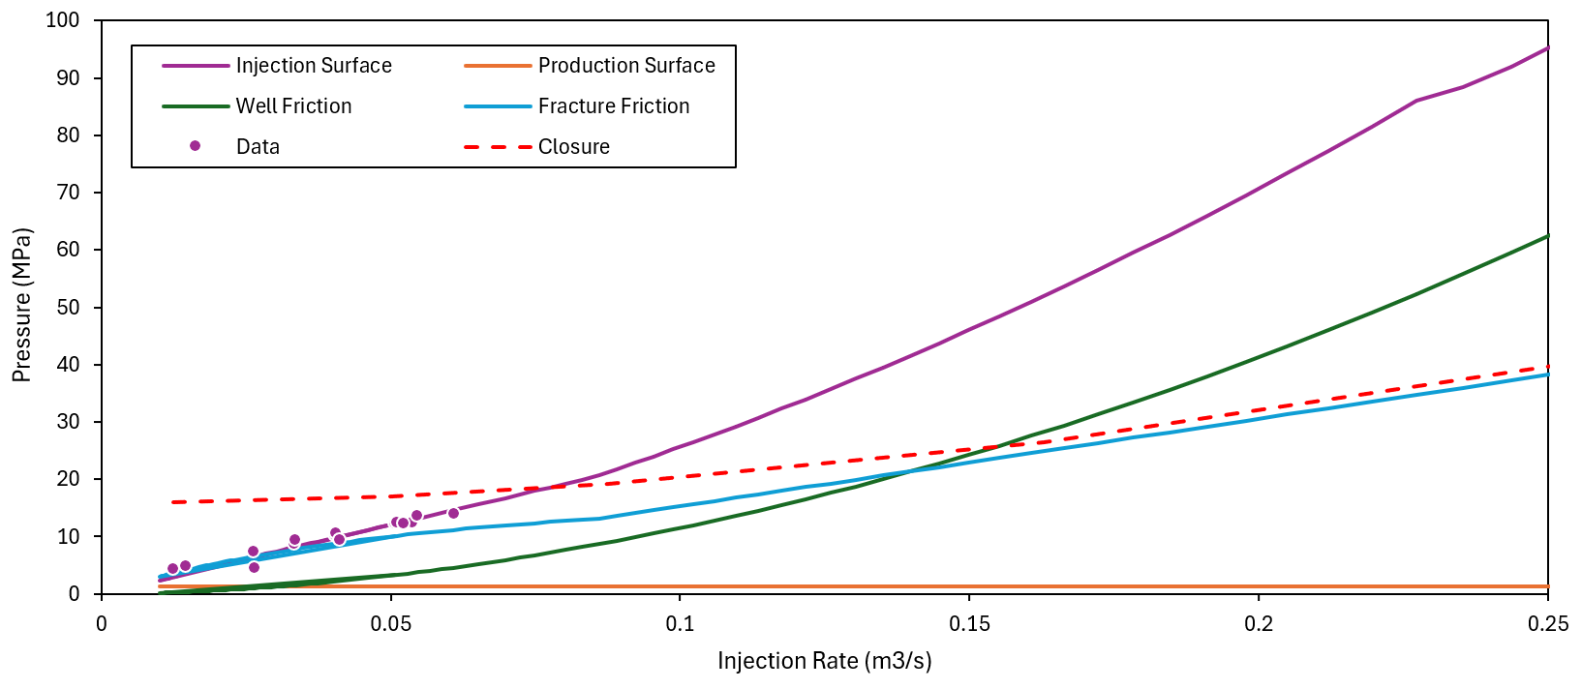
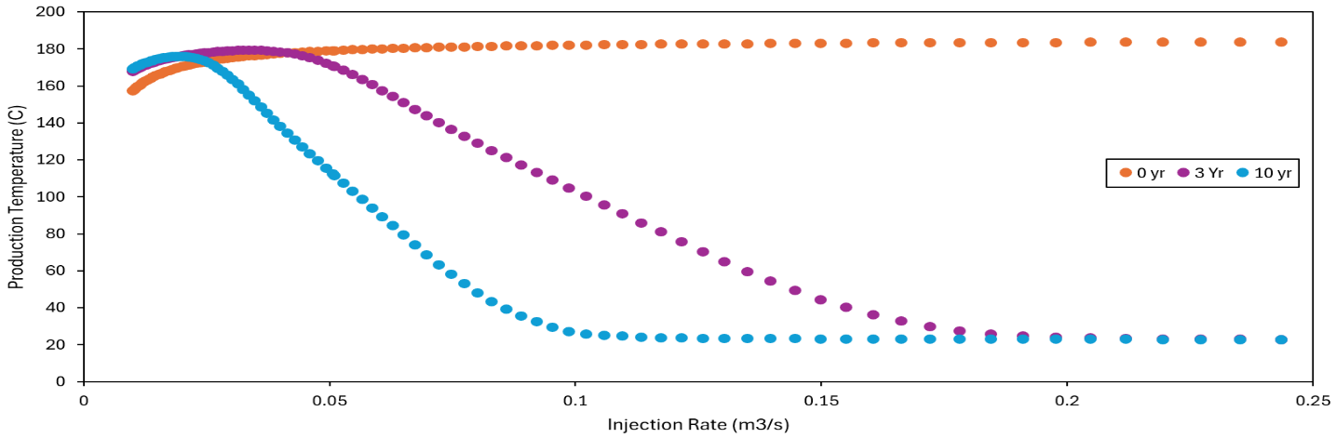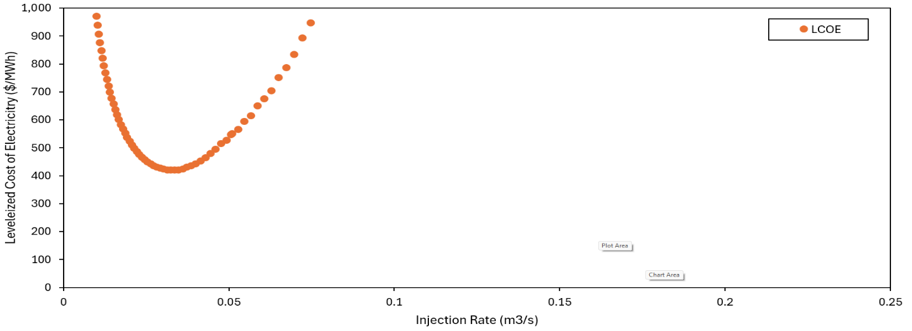
Figure 6. Surface pressures and forecast production temperature as a function of injection rate at Blue Mountain with field data overlay. Increasing flow rate brings higher parasitic losses and more rapid cooling of the reservoir. An optimum rate will yield peak economics, shown here as a minimum levelized cost of electricity.
Curiously, 11% of the top 50 closest Monte-Carlo scenarios (i.e., a-priori performance predictions) give injection pressure that exceeds the hydraulic fracture re-opening limit. The injection pressure was limited to be less than the estimated fracture opening pressure at the field site with very tight tolerances. Increased proppant conductivity would help to lower injection pressures.
The most critical predictions to validate are the long-term flow rates, pressures, and temperatures. A unique match requires a temperature decline of at least 20% because of variability in the data and non-uniqueness for the causes of this decline (e.g., heterogeneity, fracture stranding, and the effect of natural fractures). Public data for Blue Mountain omits this key information to inhibit our ability to complete this type of validation (Figure 7). Target values for history matching exercise ought to use average values (i.e., not peak), as is appropriate.
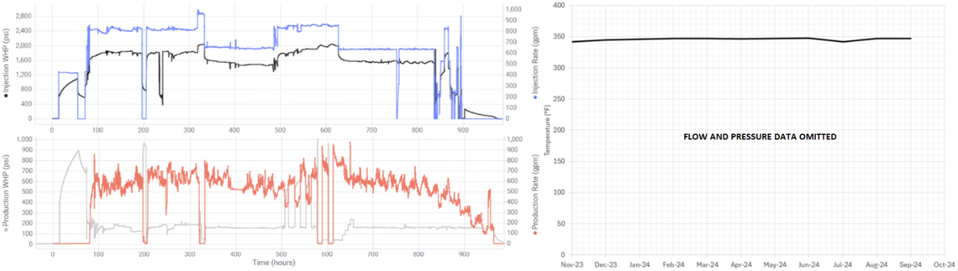
Figure 7. While Blue Mountain has arguably the best data for EGS model validation, the publicly available data omits key information. This omission prevents field validation of production temperature decline models.

Frontier Observatory for Research in Geothermal Energy Utah (FORGE)
[To be completed: Second Sand Propped EGS Site]

Fenton Hill Long Term Flow Test (LTFT)
[To be completed: Hydraulically Propped EGS]

Additional Information
For bug reporting and additional information contact the Feynman Center for Innovation at Los Alamos National Laboratory.

References
Frash, L.P. (2021). Geothermal Design Tool (GeoDT). 46th Workshop on Geothermal Reservoir Engineering, Stanford, CA, 15-17 Feb.
Gringarten, A.C., Witherspoon, P.A., Ohnishi. Y. (1975). Theory of Heat Extraction from Fractured Hot Dry Rock. Journal of Geophysical Research, 80(8): 1120-1124.
Norbeck, J.H., Latimer, T.M. (2023). Commercial-Scale Demonstration of a First-of-a-Kind Enhanced Geothermal System. Earth ArXiv.
Norbeck, J., Gradl, C., Latimer, T. (2024). Deployment of Enhanced Geothermal System technology leads to rapid cost reductions and performance improvements. Earth ArXiv.
Mouin, A., Andrews, T., Johnston, C., Singh, A., McClure, M. (2023). A new method for interpreting well-to-well interference tests and quantifying the magnitude of production impact: theory and applications in a multi-basin case study. Geomechanics and Geophysics for Geo-Energy and Geo-Resources, 9 (95).
White, M., Martinez, M., Vasyliv, Y., Beckers, K., et al. (2023). Closed-loop Geothermal Working Group Study - Understanding Thermal Performance and Economic Forecasts via Numerical Simulation. 48th Workshop on Geothermal Reservoir Engineering, Stanford, CA, 6-8 Feb.
Fu, P., Knox, H., Schwering, P., Strickland, S., et al. (2023). EGS Collab Experiment 1: Circulation Testing Processed Data. Geothermal Data Repository, https://doi.org/10.15121/1780911.

